ATHENS/SPARTA BILLBOARDS

DIRECTIONS: For this assignment you are going to first choose to live in either ancient Athens or Sparta. You are then taking a job as an advertiser, and have to choose to advertise for the military, politician or a job fair. You are going to create a beautiful advertisement to recruit someone to your cause.

You want the billboard to be eye-catching, historically accurate, and definitely fun. Base your work on the readings in the book between pages 258-269 and any other knowledge you have based on our discussions of the movie. Art supplies can be found in the drawers next to my desk, and the works should be on simple printer paper.

Option 1- Military Recruitment Poster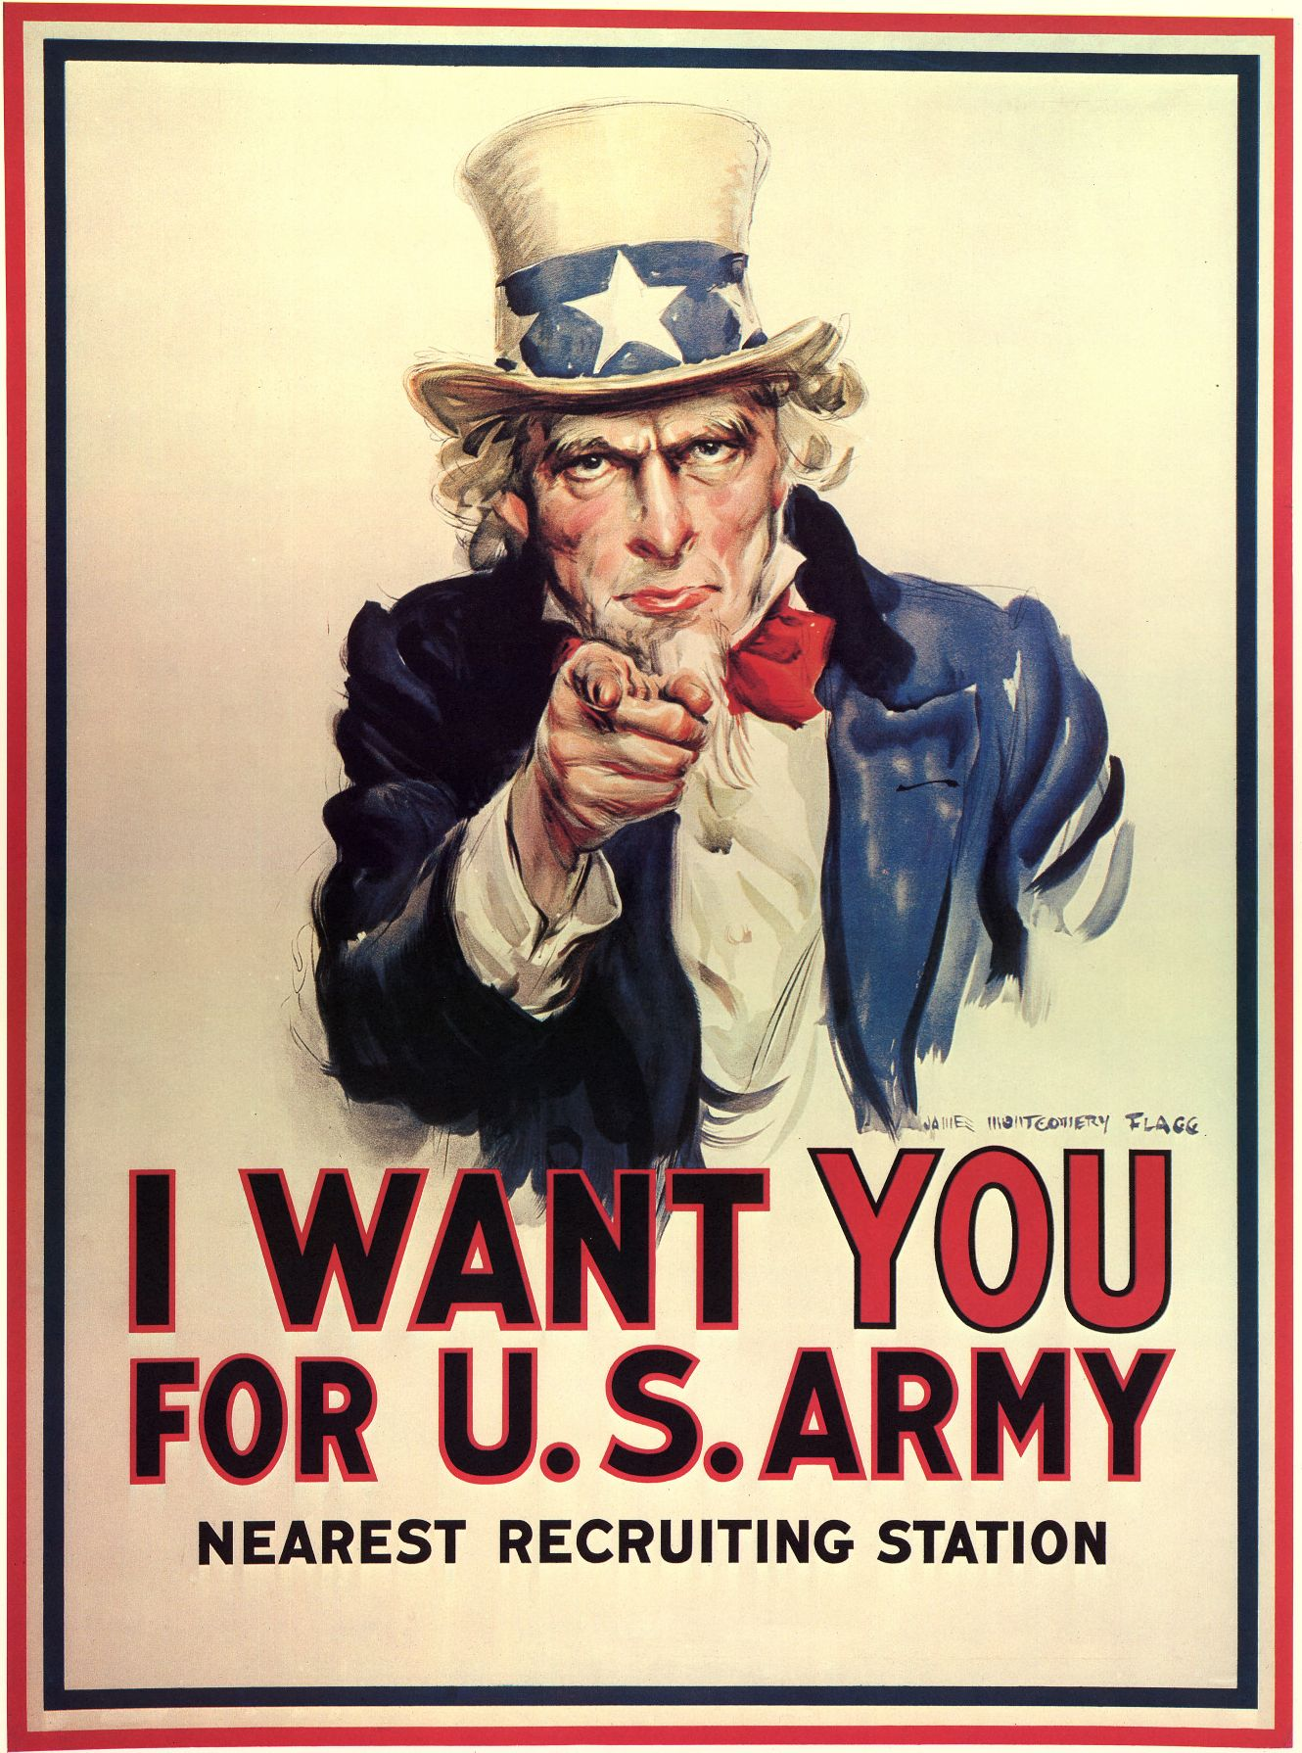

Create a “Uncle Sam” Style poster for either Sparta or Athens Military. Include all the “benefits” soldiers of each army would receive. Make it relevant to the time period and the weaponry and dress of either City-State

Option 2-Political Poster -Create a political poster for a citizen of either city state. The individual can be found in our movie work, the book, or a fictional person. You should make it sell the benefits of the city state through the poster, and the political system they use
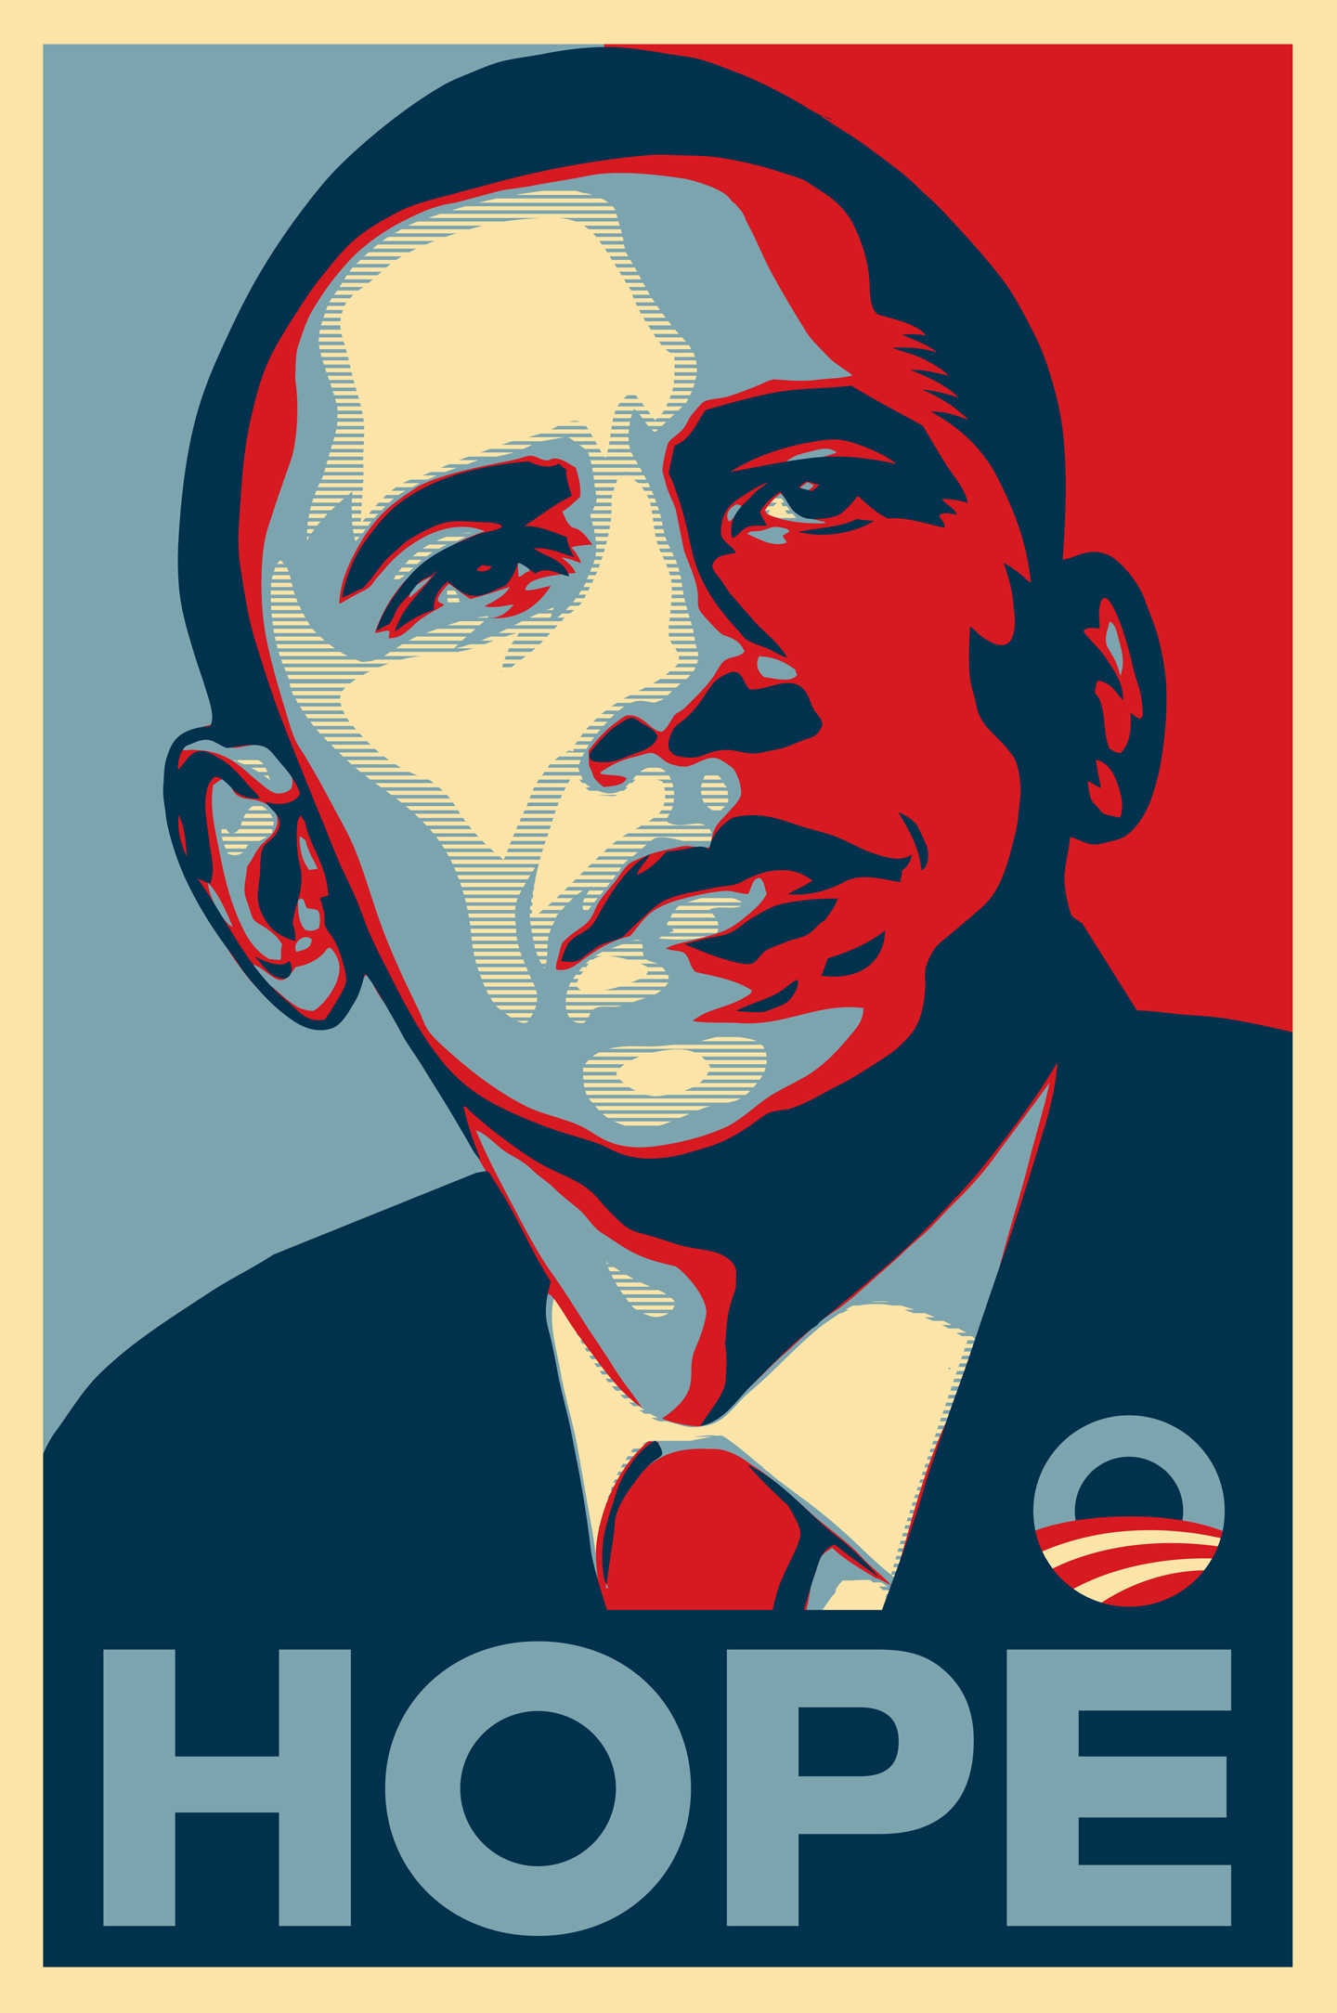

Option 3-Job Fair Recruitment Poster-
Create a poster for all of the opportunities in either city states for employment. (Some city states offer many less jobs than others ;D) List the jobs, and make the poster stand out.

GOOD LUCK AND HAVE FUN!!!

