EGYPT PYRAMID PROJECT

DIRECTIONS: For this assessment we are going to create a multi-sided artistic pyramid throughout our Egyptian unit. Each panel of the pyramid will focus on a different lesson that we study on Egypt, and students will be given in-class time between lessons to work.

Ideally the projects will stay in my classroom for safekeeping. If students choose to take the assignment home, they must make sure they do not damage the poster paper in transit. It is expensive to provide enough poster board for more than 150 students. So each student is provided 1 sheet, so please be careful.

If students are absent or fall behind on the project, they will be expected to work on their own time. Working with me during my office hours on Thursday would be ideal.

Once complete, we will hold a class wide Gallery Walk to admire and appreciate the hard work accomplished by each student.

SIDE 1 EGYPT AND SURROUNDING AREA MAP

SIDE 2 EGYPTIAN SOCIAL STRUCTURE

SIDE 3 COMPARING 3 CULTURAL UNIVERSALS (PORTLAND vs. EGYPT)

SIDE 4 SIX TRIVIA QUESTIONS AND ANSWERS

SIDE 5 (BOTTOM BASE) DETAILED TIMELINE

Details on sides are provided on the following pages
Side One 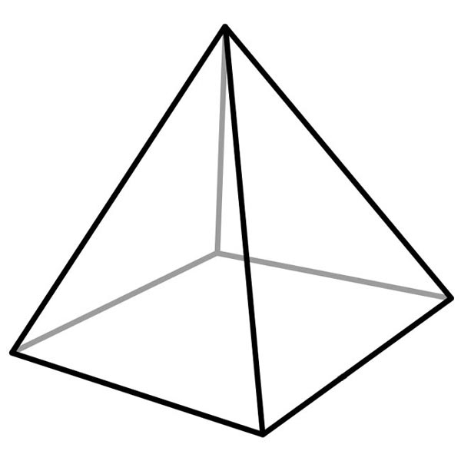

For side one of your pyramid, complete a hand drawn map of Ancient Egypt and its surrounding areas. Be neat, use color, and try to be creative!

Your map should include labels for
Asia
Africa
Canaan
Egypt
Kingdom of Kush
Kingdom of Israel
Red Sea
Mediterranean Sea
Dead Sea
Sea of Galilee
Jordan River
Nile River
Nubian Desert
Libyan Desert
Negev Desert

It should also include
Compass Rose
Scale
Key

There is a helpful map on page 64 in your History Alive! textbook, and you may also use the maps you find in the atlases found in the classroom.

Side Two

For side two of your pyramid, you should create your own illustrated example of the Ancient Egyptian Social Pyramid we studied in class. Include each of the categories and a unique illustration or visual to go along with them. Also include a written description about the lifestyle of each group. You can create the paper flaps that have the drawing on the top layer, which cover up the writing. Make sure you place each group in the right spot.
-Pharaoh/Gods
-Government officials/soldiers
-Priests
-Scribes
-Artisans
-Peasants/Farmers
-Slaves

Side Three

For side three of your pyramid, choose at least three Cultural Universals that we’ve studied. Then, compare and contrast how they work in modern day Portland vs. Ancient Egypt. You can use a Venn Diagram (Overlapping circles), other types of charts, or just write them in a way that makes sense.

Side Four

For this side, you will need to create SIX (6) trivia questions.
-Three (3) easy
-Two (2) medium
-One (1) difficult or challenging

You can display them so that the questions are on a flap and the answers are underneath. Or, if you'd like, you may put the questions and answers side by side or scattered around the page, like a trivia "matching" game.
Be creative with it!

These questions should reflect your knowledge of Ancient Egypt.

Bottom of Pyramid

For the bottom, and final side of the pyramid, you will create a timeline that shows the dates and accomplishments we discussed in chapter 8.
Should include dates for:
-The Old Kingdom
-The Middle Kingdom
-The New Kingdom
-All four pharaohs discussed in chapter 8
-The four monuments discussed in chapter 8
-At least two more things of your choice found in chapters 7, 8, and 9

