Opening Day Letter to Mr. Gershuny
Dear Class,
Hello, hello! I am writing you a letter for our first days of class, so that you can get to know me better. When you are finished, please write me back so that I can get to know you better.
I have been a teacher for seventeen years, and have taught most subjects in both middle and high school. I have taught History, Language Arts, Health, Leadership, PE and many other classes. This is my fifth year at da Vinci Middle School.
I was born and raised in N.Y., and I usually go back twice a year to visit. I moved out west in 1997 to go to college in Arizona where I majored in Sociology, Political Science and Music. I loved Tucson, and I absolutely love the sunshine!
I have two sisters, named Tara and Jill, and an older brother named Richard. My Mom and my sister all still live in NY, while my other sister Jill is raising a family in Florida. My brother and his family lives in the South American country of Columbia.
I have lived in Portland for 17 years. I moved out here in 2002 to go to Graduate school at Lewis and Clark for education, and loved it here, so I decided to stay once I finished my degree.
When I’m not teaching, one of my favorite things to do is see live music. It is my passion, and my art. I am a music photojournalist, and love to see music for free. I have written a book on music, as well as articles for Billboard Magazine. I am also very politically active, and for 10 years I was the Leader of the Oregon chapter of a national non-partisan voter registration organization called Headcount. I can also rap, and if you work really hard as a class this year you just may get to see me freestyle.
I am married to the love of my life, Mindy. She is also a teacher, and has taught Language Arts in Woodburn Oregon for 16 years. I have a four year old daughter, Izabella (Bella), and she is my everything. She just started preschool for the first time. You can see her picture on the wall over my desk. Hopefully she will be able to come visit sometime soon.
My favorite foods are sushi and lobster (I really love all seafood). My favorite sport to play is basketball, but I love to play many sports. I also love to watch baseball, football and basketball on T.V. or in person. I am a Star Wars geek (my two cats are named Luke and Leia), and I love my PS4. Two of my favorite places to go is the ocean and the forest (See why I love Portland?)
Some of my goals and dreams are: to travel around the world and set foot in every continent; to become a better teacher each year that I teach. I want to live life to the fullest, and make sure that I leave this planet in a better way than the way I find it.
I look forward to our time together. I know that we are going to get to know each other very well this year and learn a lot together!

Sincerely,
Mr. Gershuny

O.K., your turn!

You can tell me anything that you want about yourself. Please use the entire time given to write to the best of your ability.

Here’s some questions that may help to give you ideas, but feel free to come up with your own ideas. Please write me one page or more, so that I can get to know more about you.

- What kind of person are you? How would you describe yourself to someone else?

- What are you excited about when thinking of middle school? Any worries?

- What is your Art? What do you like to create?
- If someone really knew you well, what would they know about you?

- What kind of music do you listen to?
- What is your family like?
- What was your favorite class or favorite teacher like?
- What makes a good student?
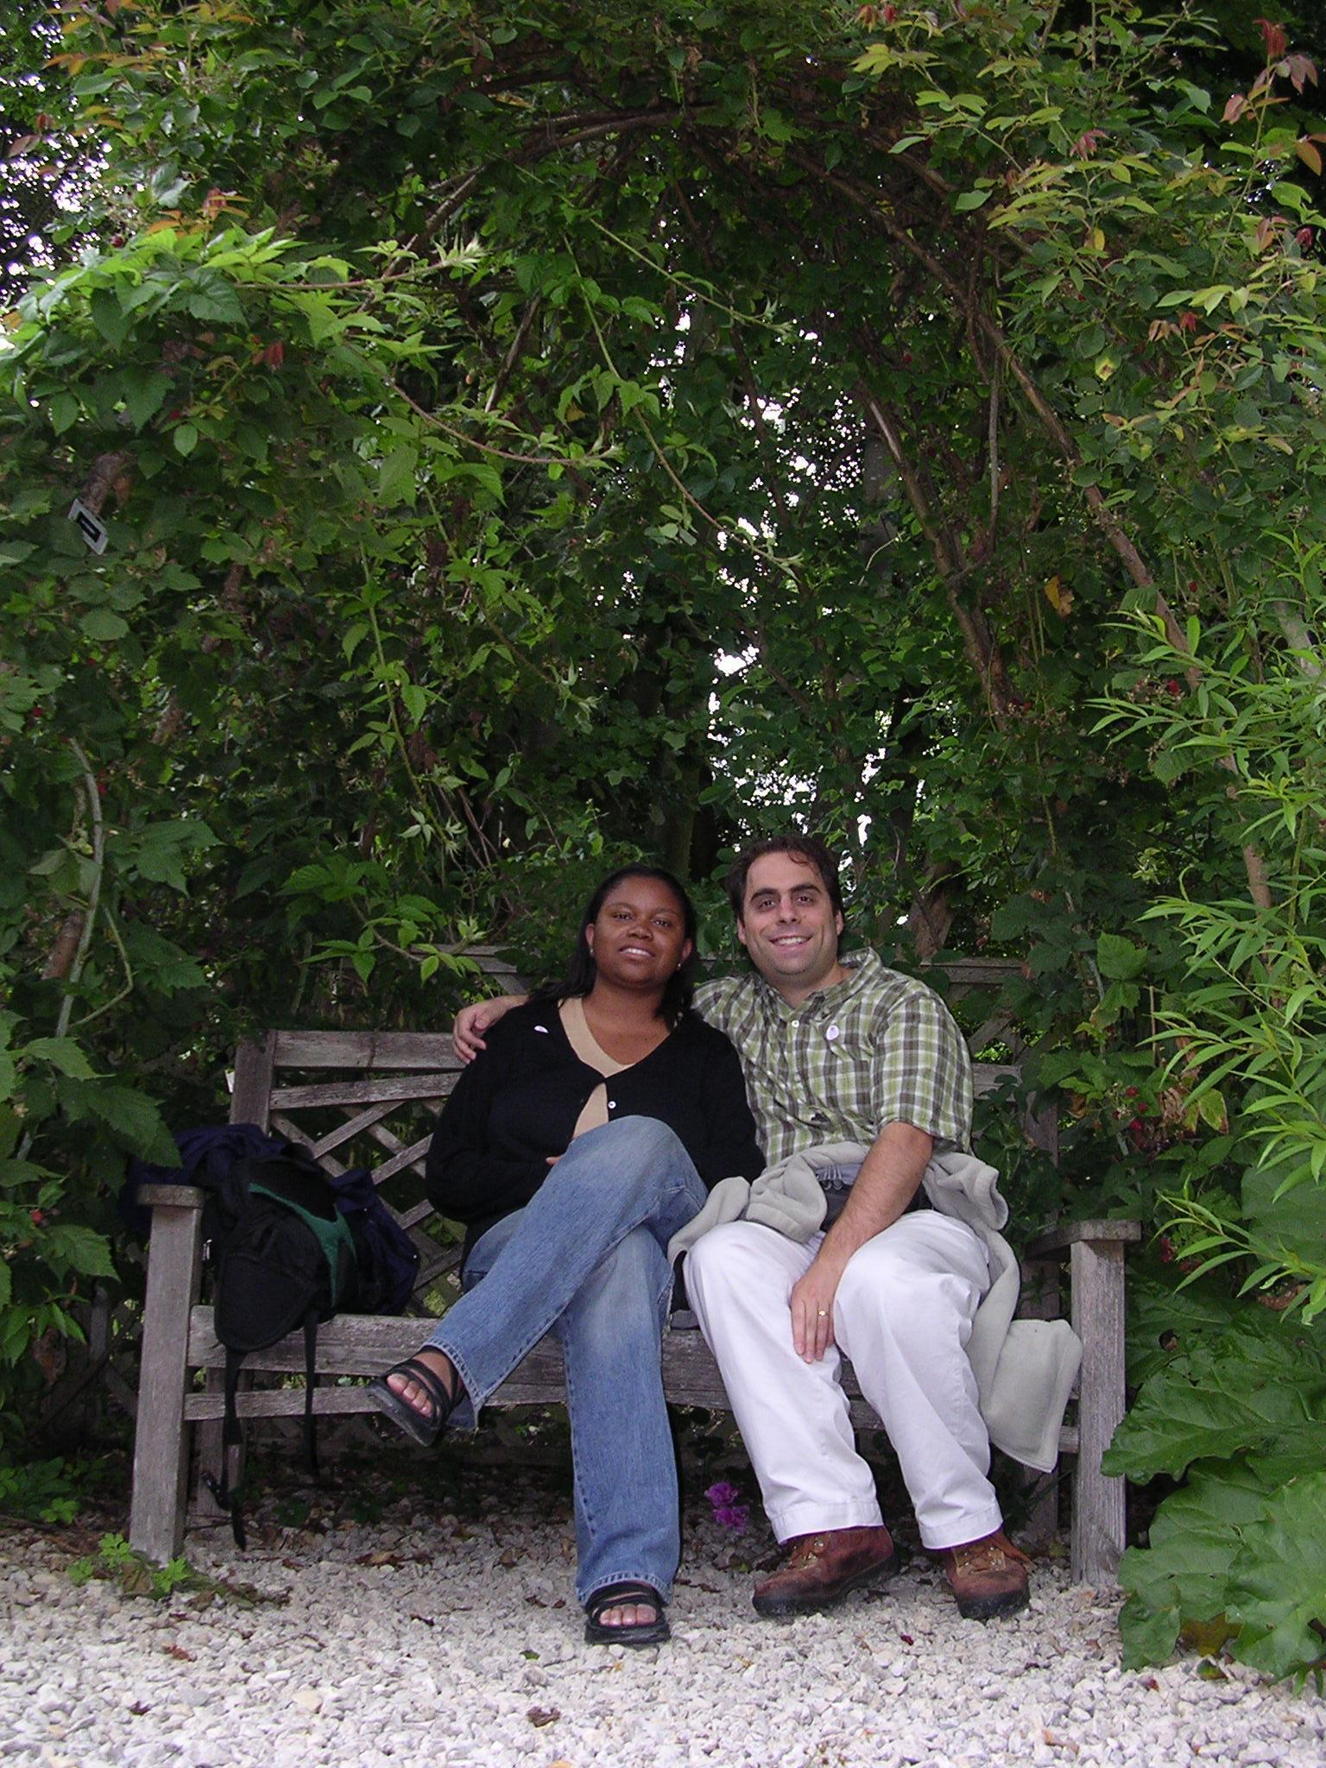
- What places have you lived in your lifetime? What places have you traveled to in your lifetime? What places would you like to see in your lifetime?
- Do you play any sports or instruments? What are your hobbies? What do you like to do for fun?
- What talents do you have? What else would you like to share about yourself?

