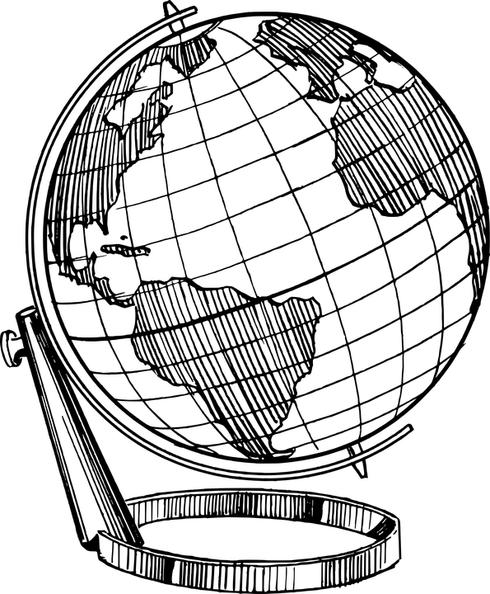
Ancient History Timeline Project

Directions: For this assignment you will work with a partner to create an artistic timeline based on our readings in History Alive!, that covers all of the ancient civilizations that we covered this year. This is the end of the year project that will hopefully connect all of these civilizations in your mind. This assignment is worth 50 points.

Expectations: Each timeline will have specific requirements to cover, and each civilization should be highlighted with a different color. Please use rulers to draw the timeline itself, and mark off time in the timeline in a consistent way (ie 1 inch equals 500 years) Please include artistic images to represent each of the major points in your timeline. Feel free to do the art on separate pieces of paper, and glue them on.

Focus on the following ancient civilizations: Mesopotamia, Egypt/Kush, India, China and Greece

Civilizations Include (if applicable):
-Starting and ending dates of the civilization
-3 major achievements of the civilization
-At least 3 leaders within the civilization
-Major events during the time of the civilization
-Inventions of the civilization

Your timeline should also focus on the 3 ancient religions we studied: Judaism, Hinduism and Buddhism

Religions Include (if applicable):

-Starting date of religion (Or in Hinduism’s case, what is the belief when it started)
-Important religious figures, their achievement, and the dates around their life
-Important historic events within the religion

